What happens if the parent and the child class have a field with same identifier? B16. Are constructors and initializers also inherited to sub classes?

Ans:

When a parent and child class have a field with the same identifier, the child class’s field hides the parent classis field. This means that if we access the field through a reference to the child class, we will get the child class’s field. However, if we access the field through a reference to the parent class, we will get the parent class’s field.

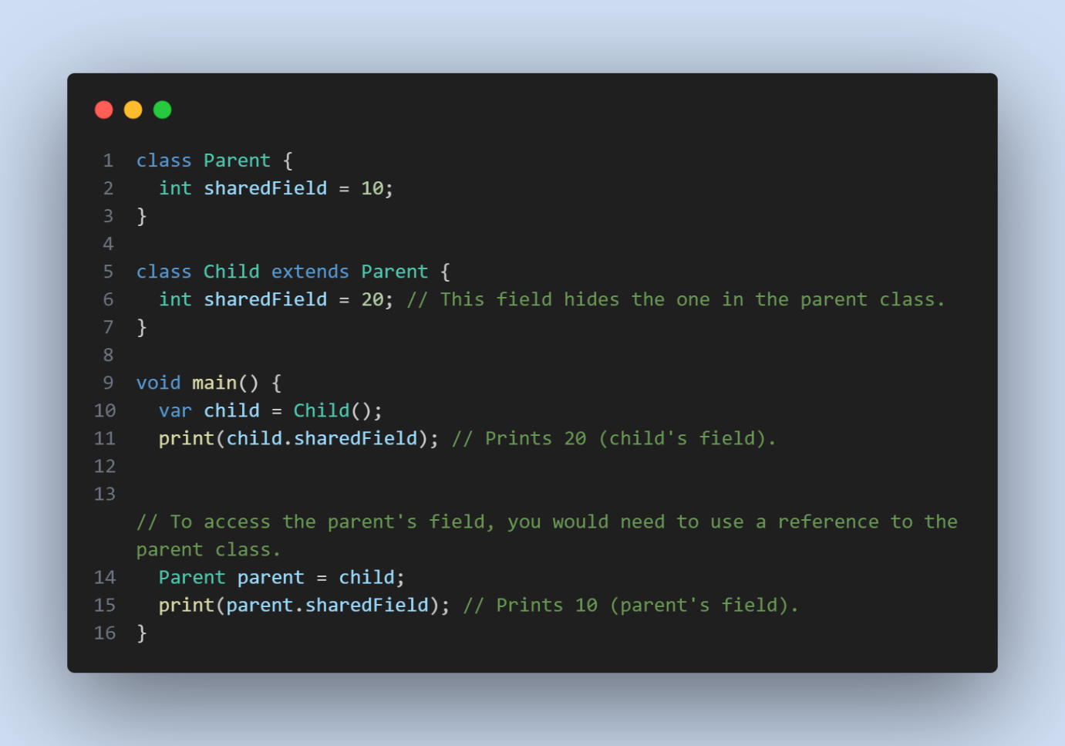

B16:

In Dart, constructors and initializers are not inherited by sub-classes. When you define a class, including its constructors and initializers, they are specific to that class and are not automatically inherited by its subclasses. Subclasses can define their own constructors, which may or may not call the constructors of the superclass explicitly using the keyword.

